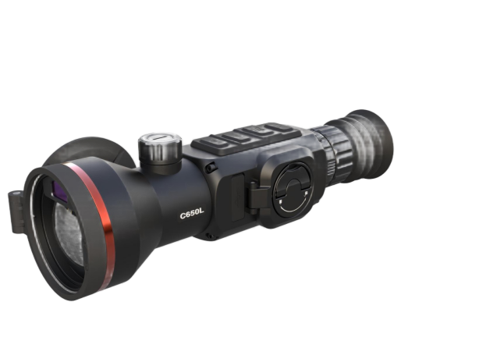

LYCAN LN635L

Thermal Scope

Thermal Image Scope is equipped with a 384 x 288 thermal detector and a 1024 × 768 AMOLED display. Boasting ultra-high thermal sensitivity, it delivers clear target recognition even in harsh weather and low temperature difference scenarios. Featuring long battery life and a maximum observation distance of 2600m, this scope is ideal for hunting, outdoor patrol, search and rescue.

Key Features
- 384×288 resolution with 12 μm sensor, 50Hz frame rate
- High sensitivity thermal module NETD ≤ 15 mK (25°C, F# = 0.9)
- 1024 × 768 resolution 0.49-inch AMOLED display
- 35mm F1.0 lens, observation distance up to 2600 m
- Up to 10 hours of continuous operation at 25°C
- 4 replaceable and rechargeable Li-ion batteries, battery non-polar design for normal operation in forward and reverse installation
- Built-in 905nm Class 1 laser rangefinder (1.2km, ±1m accuracy) and ballistic calculation
- Supports audio recording, snapshot and recoil-activated recording
- IP67 protection grade, operating temperature: -20°C ~ +50°C
- High shock resistance up to 1000 g/0.4 ms
- Wi-Fi connection and 64GB built-in storage available

n Specification
Item category | LYCAN LN335L
Thermal Module
Image Sensor | UFPA (VOx)
Resolution | 384×288
Pixel Pitch | 12µm
Frame Rate | 50Hz
NETD | ≤18mk
Spectral Range | 8-14µm
Optical Parameter
Focal length / Aperture | 35mm; F1.0
Field of View | 7.5°×5.6°
Base Magnification | 3.5X
Focusing Mode | Focus Knob
Eye Relief | 48mm
Exit Pupil | 6mm
Diopter | +5D to -5D
Detection Range | 1800m (Human; 3pixels)
Recognition Range | 450m (Human; 12pixels)
Image Display
Screen | AMOLED, 0.49 inch
Resolution | 1920×1080
Screen Brightness Adjustment | Support
Brightness Adjustment | Support
Contrast Adjustment | Support
Image Enhancement | Support
Scene Mode | City;Plain;Forest
Display Mode | Circle;Box
Color Palette | White Hot/Black Hot/Red Hot/Fusion/Golden Hot etc.
Digital Zoom | 1×; 2×; 4×; 8×
Power Supply
Battery type & Number | 4 replaceable 18350 Lithium batteries
External Power Supply | DC 5V (USB Type-C)
Power Consumption | ≤1.9W（25℃）
Battery Operating Time | ≥12h （25℃）
System
Record Video | Support
Capture Snapshot | Support
Audio Recording | Support
Local Album | Support
Recoil Activation Recording | Support
Picture in Picture | Support
Hot Track | Support
Zeroing Adaptation Mode | Support
Screen Adaptation | -
Standby Mode | Support
Ballistic Calculation | Support
Ballistic Calibration | Support
Distance Measurement | Support
Zeroing Profiles | 10
Reticle Pattern | 8
Reticle Pattern | 6
Aim Point Type | 3
Aim Point Colour | 6
BC Aim Point Type | 5
BC Aim Point Colour | 4
Ranging Cursor Type | 3
Ranging Cursor Colour | 3
Peripheral
Electronic Compass | Support
Attitude Sensor | Support
WIFI /APP | Support; 2.4G
Storage | Built-in EMMC (64GB)
Laser Rangefinder | 905nm;Class 1 Laser Safety
Ranging Distance & Accuracy | 1.2 Km*; ±1m
General
Data Transmission Interface | USB (Type-C)
Protection Level | IP67
Operating Temperature | -20°C to +50°C
Max. Recoil | 1000g/0.4ms
Weight（without battery） | ≤595g
Dimension | 238×80×65（mm）

